**Pizza Sales SQL Queries**

**KPI’s requirements:**

1. **Total revenue:**

SELECT SUM(total_price) as total_revenue from pizza_sales

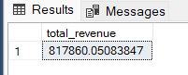

1. **Avg order value:**

SELECT SUM(total_price)/count(distinct order_id) AS avg_order_value

FROM pizza_sales;

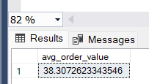

1. **Total pizzas sold:**

SELECT SUM(quantity) as total_pizza_sold

FROM pizza_sales;

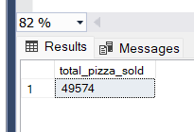

1. **Total orders:**

SELECT COUNT(distinct order_id) as total_orders

from pizza_sales

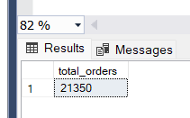

1. **Avg pizza per order :**

SELECT cast(cast(SUM(quantity) as decimal(10,2))/ cast(count(distinct order_id) as decimal(10,2)) as decimal(10,2)) as avg_pizzas_per_order

from pizza_sales

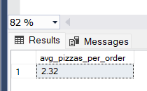

**Charts requirements:**

**1. hourly trend for total pizzas sold:**

SELECT datepart(hour,order_time) as order_hour, sum(quantity) as total_pizzas_sold

FROM pizza_sales

group by datepart(hour,order_time)

order by datepart(hour,order_time)

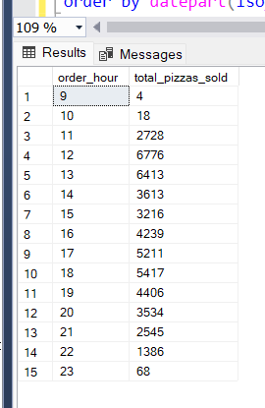

**2. weekly trend for total orders:**

select datepart(iso_week, order_date) as week_number, year (order_date) as order_year,

count(distinct order_id) as total_orders from pizza_sales

group by datepart(iso_week, order_date),year (order_date)

order by datepart(iso_week, order_date),year (order_date)

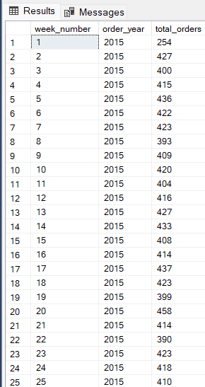

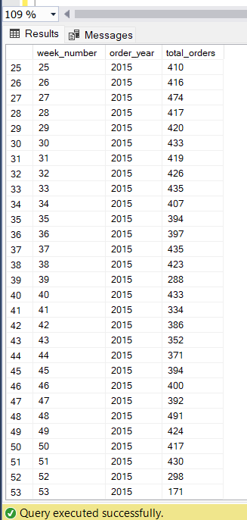

**3. percentage of sales by pizza category:**

select pizza_category,cast(sum(total_price)as decimal(10,2)) as total_sales, cast(sum(total_price)*100/(select sum(total_price)from pizza_sales where month(order_date) = 1) as decimal(10,2))as pct

from pizza_sales

where month(order_date) = 1

group by pizza_category

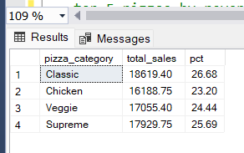

**4. percentage of sales by pizza size:**

select pizza_size,cast(sum(total_price)as decimal(10,2)) as total_sales,cast ( sum(total_price)*100/(select sum(total_price)from pizza_sales where datepart(quarter, order_date) = 1) as decimal(10,2)) as pct

from pizza_sales

where datepart(quarter, order_date) = 1

group by pizza_size

order by pct desc

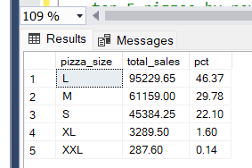

**5. a)top 5 pizzas by revenue:**

select top 5 pizza_name,sum(total_price) as total_revenue

from pizza_sales

group by pizza_name

order by total_revenue desc

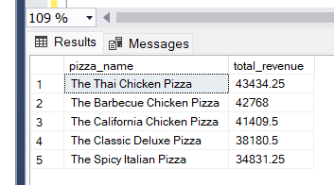

**b) bottom 5 pizzas by revenue:**

select top 5 pizza_name,sum(total_price) as total_revenue

from pizza_sales

group by pizza_name

order by total_revenue

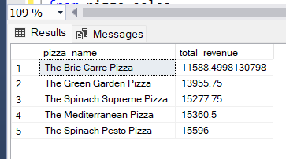

**c) top 5 pizzas by quantity:**

select top 5 pizza_name,sum(quantity) as total_quantity

from pizza_sales

group by pizza_name

order by total_quantity desc

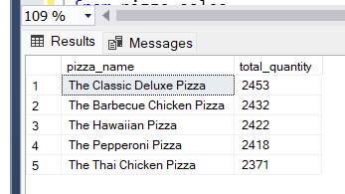

**d) bottom 5 pizzas by quantity:**

select top 5 pizza_name,sum(quantity) as total_quantity

from pizza_sales

group by pizza_name

order by total_quantity

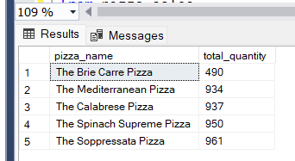

**e) top 5 pizzas by orders:**

select top 5 pizza_name,count(distinct order_id) as total_orders

from pizza_sales

group by pizza_name

order by total_orders desc

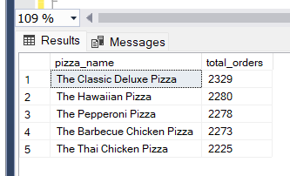

**f) bottom 5 pizzas by orders:**

select top 5 pizza_name,count(distinct order_id) as total_orders

from pizza_sales

group by pizza_name

order by total_orders

